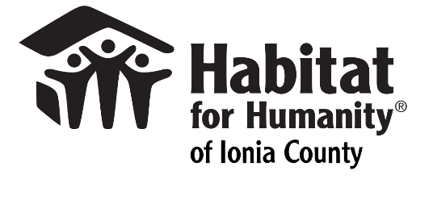

Dear Community partner,
Habitat for Humanity of Ionia County (HFHIC) is excited to be holding our Annual Golf Fundraiser on Friday, July 24, 2026 at Huckleberry Creek Golf Course in Pewamo. We would like to extend our invitation for you to be a Tee Sign Sponsor for this event. Included with your sponsorship will be a Tee Sign on the course the day of our event, recognition the day of the event and recognition on social and print media. Tee sign sponsorships are $200+.

Your commitment to improving the communities where your employees live, work and raise their families is directly in line with Habitat for Humanity of Ionia County’s mission to bring people together to build homes, communities and hope.
Tee sponsorship donations can be made at the following link/QR code or (checks made to United Way of Greater Central Michigan – desiganted to HFHIC in the memo section)
https://unitedwaygcm.harnessgiving.org/campaigns/21029

Double your impact! United Way of Central Michigan will match every donation designated to Habitat for Humanity of Ionia County, in conjunction with their Annual Golf Outing – up to $5000.
Please reference HFHIC in the memo portion of check or online donoations

Please email your company logo for the tee sign to smoore@ioniahabitat.org
With Gratitude,

Stacy A. Moore, Executive Director
(616) 523-6899
smoore@ioniahabitat.org
3192 Commerce Ln, St C3 Ionia,MI 48846

