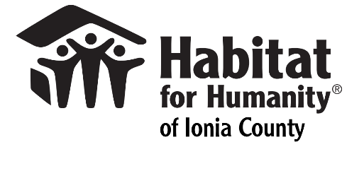
When a family is selected for Habitat for Humanity of Ionia County homeownership program, it is a life-changing opportunity
HFHIC is not a giveaway program. Homes are sold to homeowners without profit through an affordable loan paid over 15-30 years. These payments, together with donations, support the construction of homes for more families.
The selection of homeowners is done by our Homeowner Selection Committee using standard selection criteria in a way that does not discriminate based on race, gender, age, handicap, religion, marital status, or because all or part of the applicant’s income is derived from public assistance programs.
Habitat’s acceptance guidelines are based on consideration of the following criteria:

Need for Housing
The applicant(s) must demonstrate that their current housing situation has one or more of the following characteristics:
- Unsafe or very poor conditions or located in a particularly unsafe area;
- Rent, or contribution currently paid towards rent, exceeds 35% of net income;
- Size in inadequate for the present or anticipated residents;
- Other facts demonstrating a need for the type of housing Habitat can provide, that goes beyond a personal desire to own a home.

Demonstrated Ability to Pay
- Gross household income must be between 30% and 60% of the median income for the Ionia County area at the time of application.
- A two-year history of stable income and employment;
- An acceptable credit history, which includes a good record of paying rent and utilities;
- Bankruptcies must have been discharged for at least two (2) years;
- Ability to cover closing costs and adjustments, as well as a $1000 down payment on the house;
- Ability to afford anticipated mortgage payments, including property taxes and homeowners insurance;
- Monthly payments for debt cannot exceed 40% of gross monthly income;
- Applicants must be U.S. citizens or permanent residents.

Willingness to Partner with Habitat
- Applicant must complete at least 275 hours of sweat equity towards the building of Habitat homes. Applicant must comply with all other sweat equity policies;
- Applicant must be willing to live in a neighborhood in which Habitat is currently building;
- Applicant must be willing to attend required workshops for success in homeownership.

When a family is selected for Habitat for Humanity of Ionia County homeownership program, it is a life-changing opportunity
HFHIC is not a giveaway program. Homes are sold to homeowners without profit through an affordable loan paid over 15-30 years. These payments, together with donations, support the construction of homes for more families.
The selection of homeowners is done by our Homeowner Selection Committee using standard selection criteria in a way that does not discriminate based on race, gender, age, handicap, religion, marital status, or because all or part of the applicant’s income is derived from public assistance programs.
Studies show that Habitat for Humanity doesn’t just help families attain the American Dream of homeownership—the organization’s “hand up” approach helps lift families out of poverty and puts them on the road to self-sufficiency. In the short term, Habitat for Humanity increases homeownership; in the long term, its work helps to reduce the need for government subsidies. Habitat homeowners show improved health outcomes after they are settled into their new homes. And neighborhoods benefit from the stabilizing effect Habitat homeowners provide, including lower crime rates.

